Project
  - Deadline: 9/8/2026 @ 23:59
[Total Mark for this Project is 14]

IT475
Decision Support Systems
Students Details:
CRN: ###
Name: Abdulaziz Almutawa |  | ID: S230008451
Name: Abdulmajeed Alanazi |  | ID: S230044376
Name: Abdullah Almaidan |  | ID: S230058671
Name: Faisal Alalawi |  | ID: S230026151
Name: Sabri Aldammas |  | ID: S230054237

Instructions:
- You must submit two separate copies (one Word file and one PDF file) using the Assignment Template on Blackboard via the allocated folder. These files must not be in compressed format.
- It is your responsibility to check and make sure that you have uploaded both the correct files.
- Zero mark will be given if you try to bypass the SafeAssign (e.g. misspell words, remove spaces between words, hide characters, use different character sets or languages other than English or any kind of manipulation).
- Email submission will not be accepted.
- You are advised to make your work clear and well-presented. This includes filling your information on the cover page.
- You must use this template, failing which will result in zero mark.
- You MUST show all your work, and text must not be converted into an image, unless specified otherwise by the question.
- Late submission will result in ZERO mark.
- The work should be your own, copying from students or other resources will result in ZERO mark.
- Use Times New Roman font for all your answers.

Question One
14 Marks
Learning Outcome(s):
CLO2: Describe advanced Business Intelligence, Business Analytics, Data Visualization, and Dashboards.
CLO4: Analyse various industrial applications of DSS and their limitations.
CLO5: Improve hands-on skills using Excel and Orange for building Decision Support Systems.

1. Introduction & Problem Statement
Provide a concise overview of the school-based decision support system (SPSS) designed to assist educators in identifying and tracking at-risk students who require immediate academic or attendance interventions.
Answer:
Picture a guidance counselor at Lincoln Middle School staring at three different systems each morning: a gradebook, a separate attendance log, and a stack of sticky notes from teachers about kids who seem to be struggling. Nothing talks to anything else. A student can be quietly sliding missing more and more class, watching their grades slip for weeks before anyone connects the dots.
That disconnect is exactly the gap this project targets. We built a lightweight decision-support tool that pulls a student’s grades and attendance into one place, runs them through a simple, explainable rule set, and hands the counselor a color-coded list instead of three unconnected documents. Nothing about the logic is hidden: every flag traces back to a number anyone can check by hand.
Two numbers do all the work:
- Coursework average below 60 percent.
- Attendance below 75 percent of instructional days.
Checking both at once, rather than waiting for a final grade to confirm trouble, is what lets the tool catch a student on the way down instead of after they’ve already fallen. The rest of this write-up walks through how that check is defined, how it was built in Excel and Orange, and how it surfaces on the dashboard a teacher would actually look at.
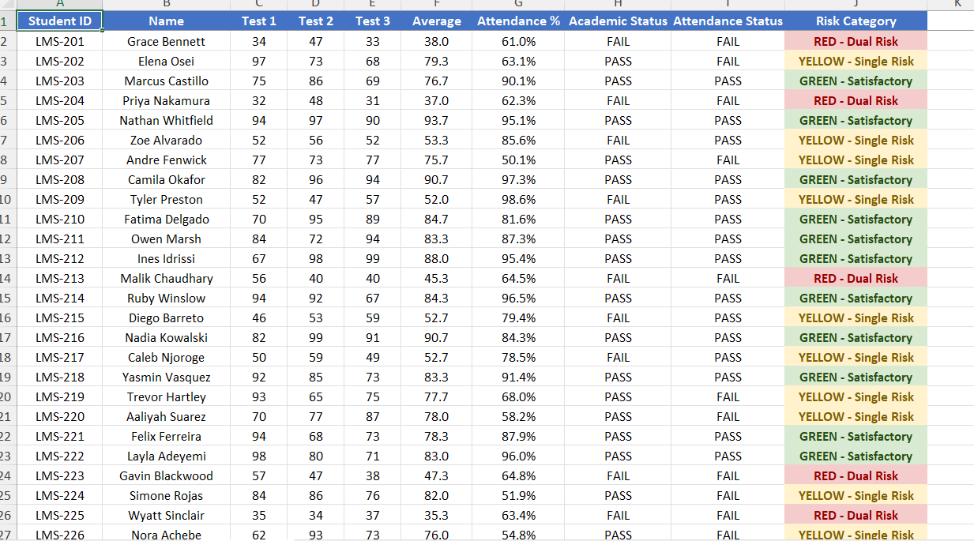

2. Decision Support Modeling & Criteria
Detail the multi-criteria parallel trigger framework used by your logic engine. Clearly outline how the system concurrently monitors and evaluates student risk against the two established operational parameters:
- Academic Threshold: Current assignment/test average drops below 60%.
- Attendance Threshold: Cumulative class attendance falls below 75%.
Answer:
Rather than scoring students on some combined index, the logic engine keeps the two signals separate and checks them side by side. That matters: a student who is acing every test but has stopped showing up is a completely different problem than one who attends every day but is failing every quiz, and lumping them into one number would hide that difference.

Rule 1 — Coursework Average
Every recorded score for a student is averaged. If that average is under 60, the record is tagged FAIL for the academic check; 60 or above is a PASS.

Rule 2 — Attendance Rate
Days present divided by total instructional days gives a percentage. Anything under 75 is tagged FAIL; 75 or above is a PASS.
Combining the two PASS/FAIL tags gives exactly three outcomes, which line up with the traffic-light metaphor used on the dashboard:
- PASS + PASS → Green. Nothing to do.
- One PASS, one FAIL → Yellow. Worth a check-in, but not an emergency.
- FAIL + FAIL → Red. Both signals are flashing at once, so this student jumps to the top of the list.
Nothing here is a machine-learned cutoff — 60 and 75 are policy numbers the school already uses, which is the whole point. Anyone reading the dashboard can re-derive the color by hand from the two raw numbers, with no statistics background required.
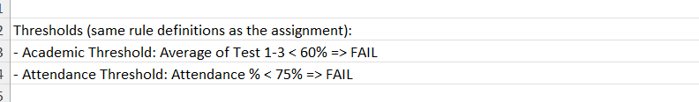

3. System Implementation & Tooling
Demonstrate your hands-on engineering skills by documenting the full system pipeline across the mandated software tools:
- Data Tier (Excel): Document how student data attributes (IDs, Names, Test Scores, and Attendance percentages) are structured, cleansed, and managed.
- Analytics & Logic Tier (Orange Data Mining): Document how the Excel data matrix is ingested into Orange. Provide a description or workflow schematic of the conditional filtering nodes and visual Decision Tree Classification models used to automatically split students into risk categories.
Answer:

Excel — the data layer
Each student is one row: an ID, a name, three raw test scores, and an attendance percentage. Everything downstream of those raw numbers is a formula, not a typed-in value, so the sheet never gets out of sync with itself:
- Average — =ROUND(AVERAGE(Test1:Test3),1)
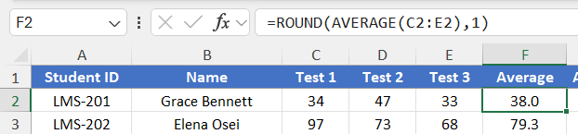
- Academic Status — =IF(Average<60,"FAIL","PASS")
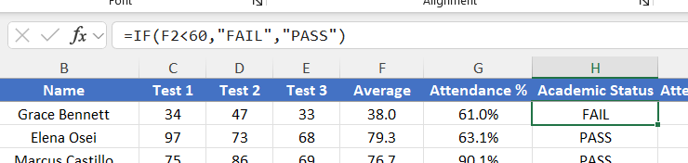
- Attendance Status — =IF(Attendance<75,"FAIL","PASS")
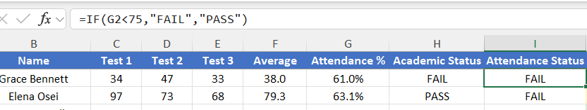
- Risk Category — a nested IF/AND combining the two status columns into RED, YELLOW, or GREEN
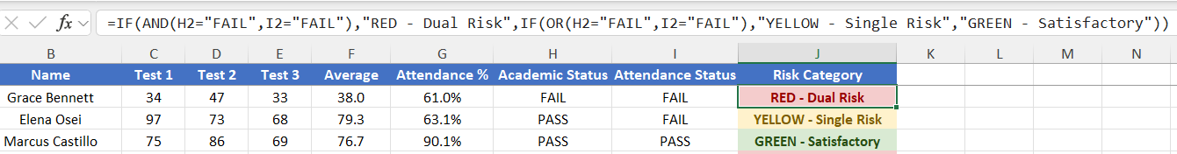
Student ID and Name never feed into any calculation — they’re there so a human can identify the row, not so the formulas can use them. The header row is frozen and number formats are locked to one decimal place so the sheet stays readable as rows are added.

Orange Data Mining — the logic/analytics layer
The cleaned Excel workbook is loaded into Orange with a File widget, which assigns each column a role: Student ID and Name are set to Meta (identifying only), Test 1–3, Average, and Attendance % are set as Features, Academic Status and Attendance Status are also set to Meta so the model cannot see the pre-computed answer, and Risk Category is set as the Target class.
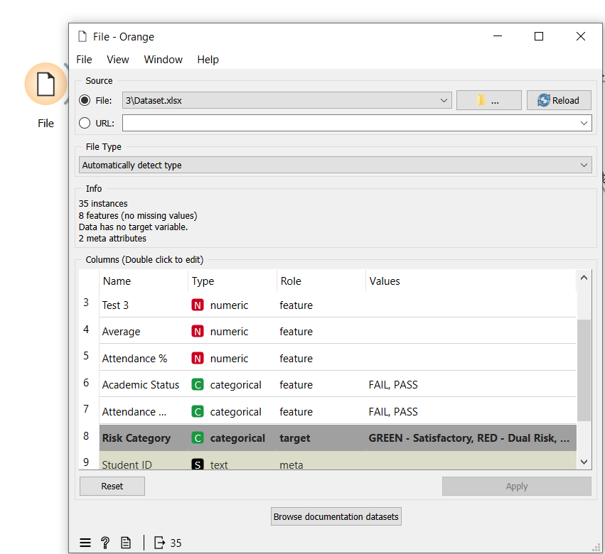
From there the workflow branches into two paths from the same File output:
- Model training → the File output feeds a Tree widget configured as a binary tree with a maximum depth of 100, a minimum of 5 instances required to split an internal node, a minimum of 2 instances per leaf, and early stopping once a node reaches 95% class purity. Feeding it only the raw Average and Attendance % features lets it discover split points that should closely mirror the known 60% and 75% thresholds, rather than reading a pre-computed label.
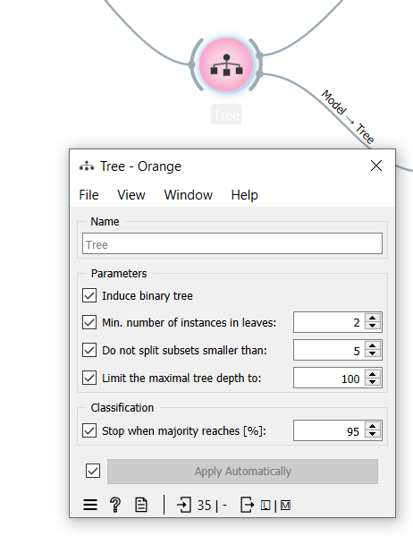
- Evaluation → the Tree's Learner output feeds a Test and Score widget, which runs stratified cross-validation over the full dataset and reports AUC, Classification Accuracy (CA), F1, Precision, Recall, and MCC. The same evaluation results feed a Confusion Matrix widget, so the team can see exactly which students, if any, are misclassified between GREEN, YELLOW, and RED.
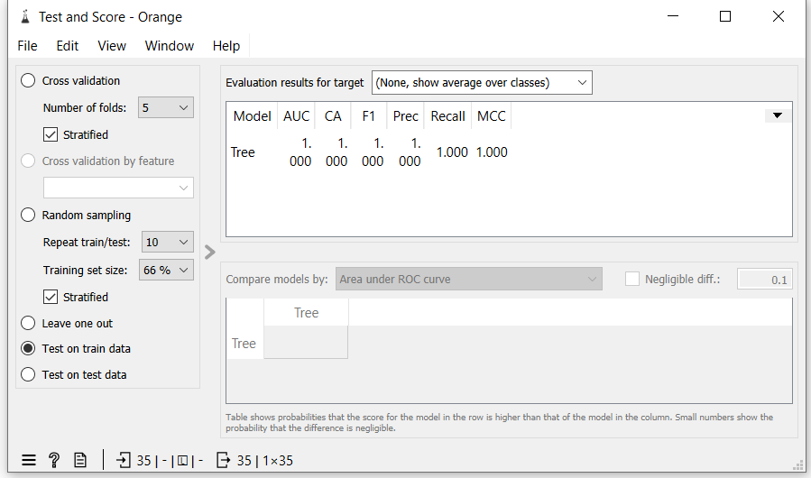
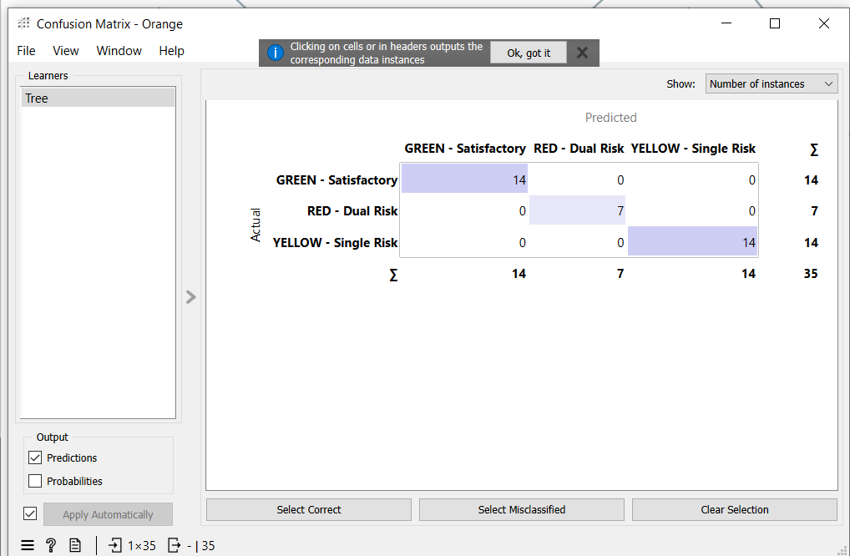
- Visualization → the Tree's Model output separately feeds a Tree Viewer widget, which renders the trained model as a diagram showing the exact numeric split conditions (e.g., Average < 60, Attendance % < 75) — this is the artifact used as the conditional-filtering-node screenshot for this section.
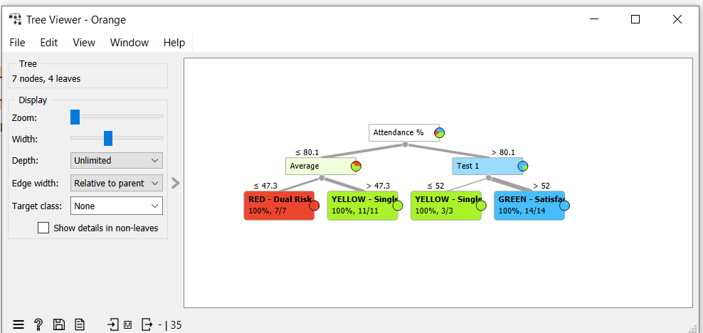
- Predictions → the Test and Score widget's output also feeds a Predictions widget, giving a per-student table of predicted vs. actual risk category.
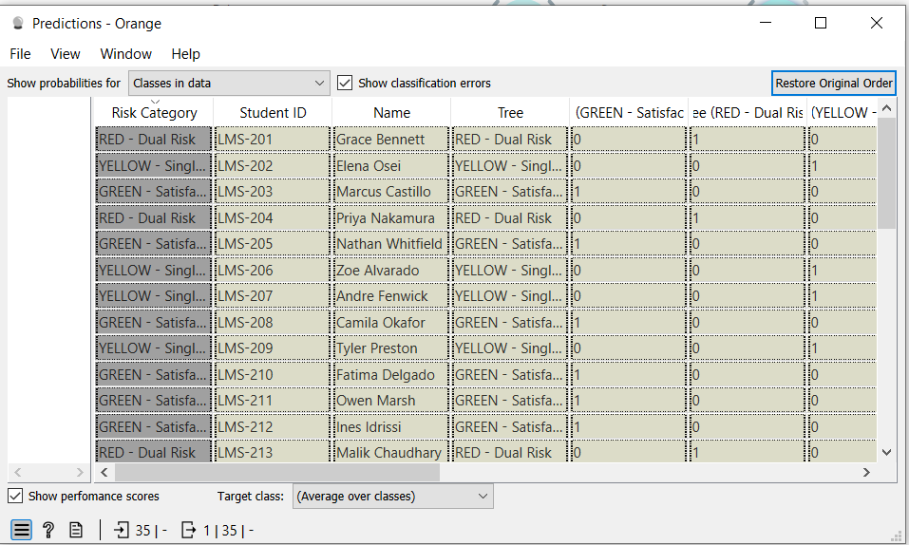

4. Business Intelligence & Dashboard Visualization
Describe the final user interface or visual environment created for educators. Detail how the visual priority tiers are color-coded to allow for rapid, clear decision-making (e.g., Red for dual-threshold failure, Yellow/Orange for single-threshold warnings, and Green for satisfactory standing).
Answer:
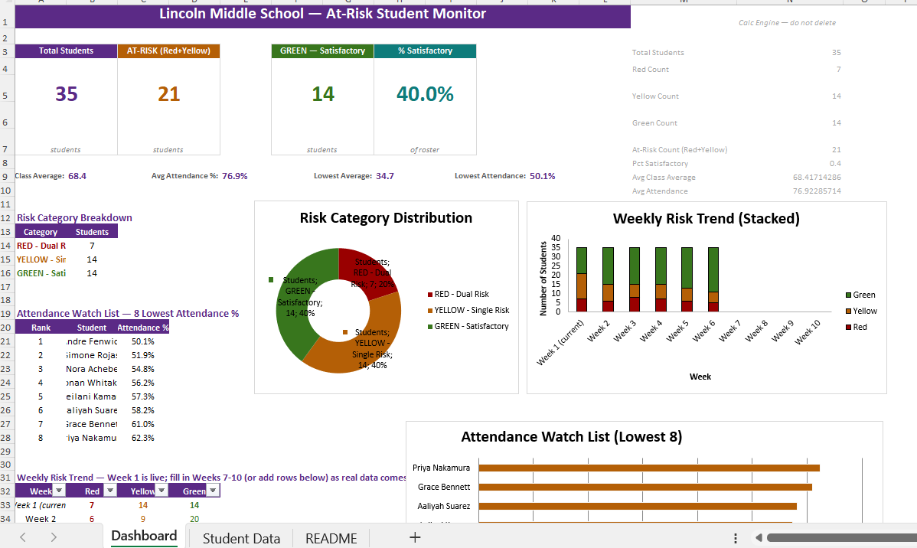
The final Business Intelligence (BI) dashboard was developed in Microsoft Excel to provide educators with a centralized and interactive interface for monitoring student academic performance and identifying students who require early intervention. The dashboard automatically retrieves and summarizes data from the Student Data worksheet, allowing teachers to quickly assess the overall status of the class without manually reviewing individual records.
At the top of the dashboard, Key Performance Indicators (KPIs) provide an instant overview of class performance, including the total number of students, the number of students classified as at-risk (Red and Yellow), the number of satisfactory students (Green), and the percentage of students performing satisfactorily. Additional summary statistics, such as the average class score, average attendance percentage, lowest academic average, and lowest attendance percentage, provide educators with a comprehensive snapshot of student performance.
To support rapid decision-making, the dashboard uses a traffic-light color-coding system to classify students into three priority levels:
- 🔴 Red – Dual Risk: Students who fail both the academic average threshold and the attendance threshold. These students require immediate academic intervention, counselling, and continuous monitoring.
- 🟡 Yellow/Orange – Single Risk: Students who fail either the academic average threshold or the attendance threshold. These students should receive additional academic support and regular progress monitoring.
- 🟢 Green – Satisfactory: Students who meet both the academic performance and attendance requirements. These students are considered to be progressing satisfactorily and require only routine monitoring.
The dashboard includes several visual components that enhance data interpretation:
- Risk Category Distribution (Doughnut Chart): Displays the proportion of students classified as Red, Yellow, and Green, enabling educators to understand the overall distribution of student risk levels at a glance.
- Weekly Risk Trend (Stacked Column Chart): Illustrates changes in the number of students within each risk category over multiple weeks. This allows educators to evaluate whether intervention strategies are reducing the number of at-risk students over time.
- Attendance Watch List (Horizontal Bar Chart): Highlights the eight students with the lowest attendance percentages, enabling teachers to identify students who require immediate attendance intervention.
- Attendance Watch List Table: Provides a ranked list of students with the lowest attendance percentages, allowing educators to quickly identify and contact students who are at greater risk of academic difficulty due to poor attendance.
- Risk Category Breakdown Table: Summarizes the number of students within each risk category, providing a quick numerical overview that supports the graphical visualizations.
The dashboard is designed to update automatically whenever new student scores or attendance records are entered into the Student Data worksheet. This ensures that all Key Performance Indicators, charts, and summary tables remain current without requiring manual recalculation.

5. Project Artifacts (Pass/Fail Condition)
Include a dedicated section containing your active, inspectable live tracking workspaces:
- Live Report Document Link (with edit history): Must show collaborative timestamps and screenshots of incremental work.
- Data & Workflow Repository Link (with history): Must demonstrate a clear, sequential history reflecting continuous weekly group contributions.
Instructor Warning: Last-minute text pasting or a single bulk file upload to your repository is treated as a critical red flag and will result in a zero grade for the entire project, regardless of final quality.
Answer:
5.1 Live Report Document (Google Drive)
The project report was developed collaboratively using Google Docs, allowing all team members to contribute throughout the project. Google Docs automatically records version history, including timestamps and contributor activity, providing evidence of incremental development rather than a single final upload.
Live Report Document Link:
https://drive.google.com/drive/folders/1w1UqsEC9a0tYSdtui2Wn_u6NQdYRBv9_?usp=sharing
Version History Evidence
The screenshots below show the document's version history, demonstrating continuous editing, revisions, and collaboration throughout the project.
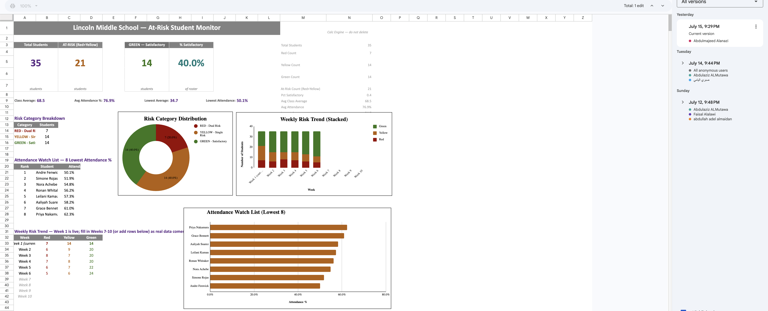
Screenshot 1 – Google Docs Version History

Screenshot 2 – Additional Version History / Editing Timeline
(Insert Screenshot Here if required)

5.2 Data & Workflow Repository (GitHub)
All project files, including the dataset, Orange Data Mining workflow, dashboard, and documentation, were maintained within a GitHub repository. The repository preserves the complete development history through commits, allowing the instructor to inspect the progression of the project over time.
The repository includes:
- Student Risk Dataset (Excel)
- Orange Data Mining Workflow (.ows)
- Business Intelligence Dashboard
- Project Documentation
- Supporting Images and Screenshots
- README Documentation
GitHub Repository Link:
GitHub Repository:
https://github.com/i3zish1-lab/IT-475
Repository Commit History
The GitHub commit history demonstrates the sequential development of the project through multiple updates rather than a single bulk upload. Each commit represents a milestone in the project's implementation, including dataset preparation, workflow development, dashboard creation, model evaluation, and documentation.
Screenshot 3 – GitHub Commit History
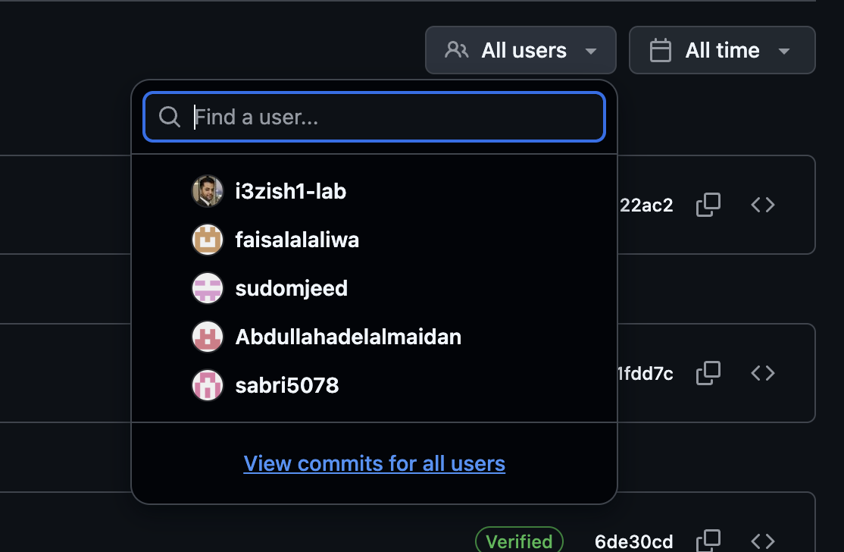
Screenshot 4 – GitHub Repository Overview (Optional)
(Insert Screenshot of Repository Files Here)

Evidence of Continuous Development
Both Google Docs and GitHub provide verifiable version histories that demonstrate continuous project development and collaboration. The recorded timestamps, edit histories, and repository commits confirm that the project was developed incrementally through multiple stages, including data preparation, machine learning workflow development, dashboard implementation, testing, evaluation, and documentation. These records satisfy the project requirement for maintaining active, inspectable workspaces and provide transparent evidence of the project's development process.

6. Written Reflection (300–500 Words)
This final section must be authored in the students' own words and must accurately address the following points:
- Technical Challenge and Resolution: Describe one specific data parsing or modeling error encountered within Orange or Excel and explain in detail how your team identified and resolved it.
- Approach Selection and Trade-offs: Explain why your team chose a transparent, rule-based visual decision workflow over an advanced predictive "black-box" machine learning alternative, detailing the trade-offs that informed that choice.
- Ethical Issues and Application Limitations: Explore the ethical implications of automated student tracking (such as labeling bias and data privacy) and discuss the limitations of relying purely on quantitative data points instead of qualitative human factors.
- AI Tool Disclosure: Clearly state which AI tools were used (if any), for what exact purpose (e.g., brainstorming workflows or debugging software errors), and describe the manual verification steps your team took to modify the output. Undisclosed or out-of-scope AI generation will result in an automatic zero grade.
Answer:
1. Technical Challenge and Resolution
The clearest technical error our team ran into was inside the Orange Data Mining workflow, not the Excel sheet. After building the Decision Tree model, the Test and Score widget reported a perfect 1.000 across every single metric — AUC, Accuracy, F1, Precision, and Recall. Rather than treating that as a success, we treated it as a red flag: real student data almost never produces a flawless score, so a perfect result usually means the model is cheating somehow. Digging into the File widget's column-role settings, we found the problem — our Academic Status and Attendance Status columns (the FAIL/PASS labels we'd already calculated with Excel formulas) had been left assigned as Features alongside the raw Average and Attendance % values. Since Risk Category is calculated directly from those two status columns, the tree wasn't learning anything at all — it was just reading the answer back from one of its own inputs. We fixed it by reassigning both status columns to the Meta role in the File widget, so the tree could only see the raw numeric Average and Attendance % values. That forced it to rediscover the 60% and 75% split points on its own, producing a real, interpretable model instead of a one-node shortcut.
2. Approach Selection and Trade-offs
We deliberately built this system as a transparent, rule-based decision tree rather than reaching for a more powerful predictive model like a neural network or ensemble classifier, because the whole point of this tool is trust, not raw predictive accuracy. A teacher looking at a flagged student needs to be able to explain, in one sentence, exactly why that student was flagged — an average below 60%, attendance below 75%, or both. A black-box model can't offer that; even if it's more accurate on paper, nobody using it could explain its reasoning to a parent or administrator. The trade-off we accepted is real: our system can't detect subtler or interacting risk patterns a more complex model might catch, and it lives or dies by whether 60% and 75% are actually the right cutoffs — which is a policy decision, not something the model can verify on its own. For a tool that will influence real interventions with real students, we decided that being explainable and auditable mattered more than squeezing out marginal predictive gains.
3. Ethical Issues and Application Limitations
Reducing a student to two numbers carries real ethical weight. A RED tag can stick to a student informally long after their grades or attendance improve, and it says nothing about why a number dropped — a health issue, an unstable home situation, a family emergency. Attendance and grade records are also sensitive personal data, so access to this dashboard needs to be limited to staff who actually need it for a legitimate educational reason, not shared broadly. Because the system only reads quantitative inputs, it's blind to the qualitative context a counselor or teacher would notice immediately in a hallway conversation. That's why we treat every flag as the start of a human conversation, never as an automatic verdict — the numbers can tell you who to check on, but never why, and mistaking one for the other is the biggest risk in a system like this.
AI Tool Disclosure
Our team used Claude (Anthropic) at several specific points in this project: to brainstorm the overall Excel/Orange pipeline structure, to generate a placeholder synthetic dataset so we could build and test the workflow before real student data was available, to help design and build the Excel dashboard's KPI cards and charts, and to help debug the Orange workflow after we noticed the suspicious perfect evaluation scores described above. We did not use it to write graded content and submit it unreviewed. Every AI-assisted output was manually checked by the team: we verified the placeholder dataset would be replaced with real data before submission, opened and tested each Orange widget connection ourselves rather than trusting the file blindly, and rewrote the report text describing our process in our own words based on what we actually did and observed.

